GETTING STARTED WITH PYTHON
INTRODUCTION
Python is a widely used general-purpose, high level programming language. It was initially designed by Guido van Rossum in 1991 and developed by Python Software Foundation (https://www.python.org/psf/). It was mainly developed for emphasis on code readability, and its syntax allows programmers to express concepts in fewer lines of code.
The most recent major version of Python is Python 3, which we shall be using in this workshop. However, Python 2, although not being updated with anything other than security updates, is still quite popular.
WHAT CAN PYTHON DO?
- Python can be used to handle big data and perform complex mathematics.
- Python can be used on a server to create web applications.
- Python can be used alongside software to create workflows.
- Python can connect to database systems. It can also read and modify files.
- Python can be used for rapid prototyping, or for production-ready software development.
INSTALLING PYTHON THROUGH MINICONDA
There are two options for getting Conda: Anaconda and Miniconda. Anaconda is a full distribution of Python, and comes with over 150 packages in the download. Consequently, this download is over 3 GB. Anaconda is good if you want to have many packages downloaded and available in one shot. This is especially useful if you know you will be working offline for awhile. In this workshop, we will install Python through Miniconda. Miniconda contains only Python and other libraries needed to run Conda itself. Other packages will be downloaded and installed as requested, thereby decreasing the size and time of the download.
To install Miniconda, follow these steps:
- Navigate to the Miniconda download page: Miniconda
- Select the Python 3.7 installer for your computer's operating system.

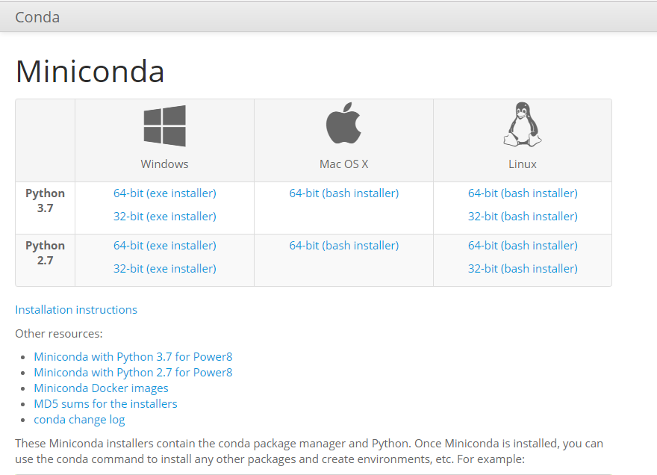

- Locate the installer that you downloaded using Explorer (Windows).
- Run the installer.
- Follow the installation instructions provided by the installer.
To test whether your installation was successful:
- Select the Start button on your Windows taskbar.
- Type cmd.
- Click Command Prompt from the list.

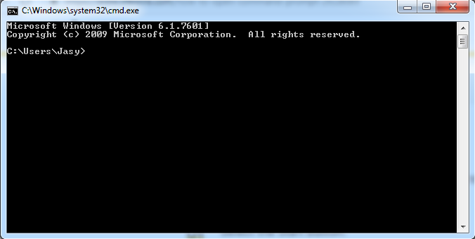

- Type the following command into your terminal:
conda list

You should see a list of all the packages that Miniconda installed. If you are on a computer that uses Windows, you may have to first navigate to the folder where you installed Miniconda for the conda list command to function properly.
MANAGING PACKAGES IN MINICONDA
The Python language, however, doesn't come pre-installed with all of the fancy features you might want (or require), even when installed using Miniconda. When you need particular functionality, you can look for Python packages. A package structures Python modules, which contain pre-written code that other developers have created for you. Modules are handy when you are looking for specific functionality.
Usually, pip is used to install and manage Python packages. It is the package manager for the official Python distribution. If you installed Python with Miniconda, the package manager is not pip, the package manager is conda.
Just like pip, you can use conda to install packages, like so:
conda install scipy

In the example above, conda will install the SciPy package, a popular package (among many) used for mathematics with Python.

